Enhancing Mineral Exploration Using Hyperspectral Imaging and Dual Regression Reflectance Conversion

Drashya Sodha, Karka Roahn. Ujjwal Tiwari, Ashish Nikam, Deepa Parasar
^{1,2,3,4,6}FComputer Science & Engineering Department, Amity School of Engineering & Technology, Amity University Maharashtra, Mumbai, India
*deepaparasar@gmail.com

Keywords: DENOISING, HYPERSPECTRAL IMAGING, IMAGE PROCESSING, MINERAL DETECTION, REMOTE SENSING.

Abstract
This paper proposes a novel, automated system for mineral detection using hyperspectral imaging (HSI), with a focus on kaolinite identification. Unlike traditional approaches, our method introduces a dual regression model that learns to convert top-of-atmosphere (TOA) reflectance to bottom-of-atmosphere (BOA) reflectance, treating atmospheric correction as a denoising problem. The model is trained on paired TOA-BOA reflectance data and supports bidirectional learning for improved stability and spectral fidelity. Post-correction, spectral angle mapping is used to identify mineral presence from spectral libraries. Experimental results on EnMAP satellite imagery demonstrate high accuracy and spatial reliability, confirming the model’s effectiveness. This work bridges atmospheric correction and mineral classification into an end-to-end framework, enabling scalable, real-time applications in mineral exploration.
- Introduction
Mineral detection and mapping are crucial in industries such as mining, environmental monitoring, and planetary exploration, providing foundational insights for sustainable resource management. Traditional methods, including field sampling and laboratory analysis, are often labour-intensive, time-consuming, and costly, making them impractical for large-scale or remote areas. Remote sensing techniques, such as multispectral imaging, have improved efficiency but face limitations in differentiating closely related minerals due to their limited spectral resolution. Hyperspectral imaging (HSI) has emerged as a transformative technology, addressing these limitations by capturing continuous spectral information across hundreds of narrow bands from the visible to thermal infrared regions. This capability enables precise mineral identification based on unique spectral signatures related to the intrinsic physical and chemical properties of minerals, thereby enhancing detection and mapping accuracy [1][11].

2 Literature Review
Recent literature reflects a growing interest in hyperspectral imaging (HSI) as a powerful tool for mineral identification and mapping, thanks to its ability to capture rich spectral information across hundreds of narrow bands. Researchers have explored a variety of techniques to make sense of this high-dimensional data while addressing challenges such as noise, redundancy, and processing complexity [9]. For instance, Yousefi et al. highlight the effectiveness of Sparse Principal Component Analysis (Sparse-PCA) in reducing both dimensionality and spectral noise. When combined with kernel-based classifiers like Extreme Learning Machines (ELM), this approach has led to significant improvements in feature selection and classification accuracy [17]. Kruse emphasizes HSI’s advantages over traditional laboratory methods such as X-ray diffraction and chemical assays. By enabling rapid, non-destructive, and quantitative analysis—especially in drill core evaluations—methods like Spectral Angle Mapper (SAM) and Linear Spectral Unmixing have become widely adopted in operational settings [4][10][18]. The practical applications of HSI extend further, as shown by Hasan et al., who demonstrate its utility in mapping alteration zones and mineral distributions with high spatial and spectral resolution. However, they also note persistent challenges, particularly the computational burden and the need to tailor models to specific geological regions [3]. In response to such limitations, Krupnik and Khan explore the integration of HSI with complementary datasets like LiDAR and advanced machine learning models—including convolutional neural networks (CNNs) and Gaussian processes. These hybrid approaches aim to enhance both the accuracy of mineral mapping and the safety of mining operations, albeit with increased complexity and data processing demands [19][20].
Deep learning continues to gain momentum in this field. Okada et al., for example, investigate the use of CNNs to automate mineral classification tasks. Their work demonstrates the potential for achieving high accuracy and real-time processing capabilities, overcoming several bottlenecks associated with traditional, hand-engineered methods [13]. Similarly, Ren et al. propose a framework that combines Nonnegative Matrix Factorization (NMF) with clustering and spectral matching. This hybrid model not only reduces noise but also boosts computational efficiency, accelerating hyperspectral data analysis [2]. At a broader scale, reviews by Sabins et al. and Ahamadou et al. underscore the role of remote sensing—and HSI in particular—in global mineral exploration. Their findings stress the importance of integrating hyperspectral data with geophysical inputs to delineate hydrothermal alteration zones, especially in arid or exposed terrains. Yet, they also point out the limitations posed by vegetated or soil-covered surfaces, where spectral signatures are more easily obscured [12].
Finally, Wenzheng et al. and Manolakis and Shaw trace the evolution of spectral matching and target detection techniques. They note a shift from simple metrics like SAM to more robust fusion-based and machine learning approaches. These newer methods offer greater resilience against spectral variability and environmental noise, aligning well with the ongoing push for more adaptive and data-driven exploration pipelines [8][21][22].
3 Proposed Model Implementation
The proposed system operates as a complete automated pipeline which detects minerals through hyperspectral satellite imagery with specific emphasis on kaolinite detection. The system implements a dual regression model that treats the process of converting TOA reflectance to BOA reflectance as a denoising operation. The method successfully eliminates atmospheric interference to produce clearer surface reflectance data which enables accurate mineral identification [14].
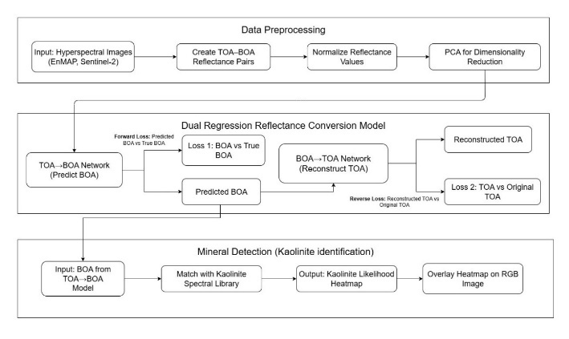

Fig.1 Proposed System Flow Diagram

3.1 Functional Decomposition
The table design follows the example format without any column lines unless they help readers understand the table data. The table rows should include lines to separate the header section from the rest of the content.

The EnMAP (Environmental Mapping and Analysis Program) hyperspectral imager (HSI) serves as the primary data source for this research because it operates as a leading spaceborne instrument for Earth surface observation at high resolution. The EnMAP hardware system operates to acquire detailed spectral information through its shortwave infrared and visible spectrum range from 420 nm to 2450 nm. The wide spectral range of 420 nm to 2450 nm enables precise identification of surface materials through their unique absorption characteristics [16]. The system starts with hyperspectral image preprocessing of satellite data which arrives in .hdr and .raw format from EnMAP and Sentinel-2 platforms. The preprocessing stage involves precise image alignment of TOA (Level-1B) and BOA (Level-2A) data to generate reflectance pairs that maintain both spatial and spectral accuracy. The correct alignment of TOA-BOA pairs becomes essential because these pairs serve as the base for model training and loss evaluation. The reflectance data undergo normalization to achieve uniformity between different scenes and sensors which helps minimize performance-degrading variability. The data processing includes Principal Component Analysis (PCA) which decreases data dimensions while improving computational speed and possibly boosting model performance. The dual regression reflectance conversion model serves as the central component of the system because it operates with paired TOA and BOA images. The TOA-to-BOA network uses data-driven methods to convert atmospheric reflectance into surface reflectance while performing denoising and atmospheric correction operations. The BOA-to-TOA network generates the original TOA reflectance from predicted BOA output which creates a two-way learning system that enhances both stability and accuracy. The model training depends on two main loss functions which evaluate the difference between predicted BOA values and actual BOA values and the difference between reconstructed TOA values and original TOA values. The model receives its training data from aligned TOA-BOA pairs which enable it to develop an accurate spectral relationship between these domains.

The system advances to mineral detection operations after producing the BOA reflectance image from the model output. The Spectral Angle Mapper (SAM) algorithm compares each pixel in the BOA image spectral signature to kaolinite reference spectra from the library to determine kaolinite presence likelihood across the image. The system generates detailed spatial heatmaps through signature matching which enables further scientific evaluation and decision support. The system overlays the generated heatmap onto the original RGB satellite image to create an actionable visualization for scientific analysis. Mathematically, SAM is computed using the vector dot product of the spectra, which is why it is also referred to as the dot-product angle between spectral vectors. For two non-negative spectral vectors SSS and TTT, the angle distance θ is defined using the following analytical expression:

$$θ=\cos^{-1}{\frac{\int{S( λ) T( λ) dλ}}{{[\int{S{(λ)}^{2}dλ}]}^{1/2}{[\int{T{( λ)}^{2}}dλ]}^{1/2}}}$$

The SAM algorithm computes the cosine similarity between each spectrum in the hyperspectral image (HSI) and the known target spectrum provided as a reference. While SAM demonstrates strong performance in distinguishing between different materials, its effectiveness diminishes when detecting targets that closely resemble similar materials. Additionally, the algorithm lacks optimality properties, even when applied to classes with multivariate normal distributions.

3.2 Data Flow and Integration
The data flows sequentially through the system, starting with the ingestion and preprocessing of raw satellite images. These images are then aligned and normalized, and, if necessary, undergo dimensionality reduction. The paired TOA and BOA images are fed into the dual regression model, which outputs a denoised and atmospherically corrected BOA reflectance image. This image is subsequently analyzed for kaolinite presence through spectral matching, and the results are visualized as a heatmap overlay on the original satellite imagery. Each stage is tightly integrated to ensure that the output of one phase seamlessly supports the objectives of the next, leading to a highly efficient and accurate mineral detection workflow.

3.3 Details of Software
The software is organized into three primary modules: Data Preprocessing: This module handles hyperspectral images typically provided in .hdr and .raw formats from satellite sensors such as EnMAP and Sentinel-2. It aligns paired TOA (Level-1B) and BOA (Level-2A) images stored in separate directories, normalizes reflectance values to maintain consistency across different scenes and sensors, and optionally applies Principal Component Analysis (PCA) to reduce data dimensionality and improve computational efficiency. The framework contains a dual regression reflectance conversion model that uses a bidirectional neural network structure. The system contains two networks which perform two functions: the first network generates BOA reflectance from TOA input data and the second network generates TOA reflectance from BOA predictions. The dual learning system maintains stable reflectance mapping through its approach which detects atmospheric transformation complexities without needing physical models or explicit correction parameters. The training objective uses two loss functions to achieve its goal: it calculates the difference between predicted BOA reflectance and actual BOA reflectance values and it measures the difference between reconstructed TOA reflectance and its original value. The method maintains spectral fidelity because it preserves accurate mineral detection results in subsequent processing stages.
The trained dual regression model functions as a data-driven system which learns to forecast BOA reflectance from TOA data through the use of labeled training examples. This model generalizes well to noisy or incomplete inputs and, once trained, can process large hyperspectral datasets almost instantly using GPUs. The model works best for real-time processing and onboard satellite deployment and cloud applications. The model has the ability The model's performance relies on the quality and representativeness of the training data it receives.

3.4 Strengths and Impact
The system's automated features reduce human involvement needed for both atmospheric correction and mineral detection of minerals. The system produces high-quality reflectance conversion through its denoising approach and its training process with TOA-BOA reflectance pairs that are precisely aligned. The system maintains spectral fidelity throughout its entire process which leads to more accurate scientific results. The system generates a heatmap overlay as its final output which provides direct actionable information for mineral exploration and environmental monitoring purposes.
The system provides end-to-end automation while showing excellent performance across multiple sensors and imaging scenarios and it operates efficiently with large datasets. The system provides excellent performance in real-world applications because it handles metadata inconsistencies and scene variations better than traditional atmospheric correction methods. The model depends on learned transformations for its operation which results in a lack of physical transparency that traditional physics-based approaches provide. The system provides practical and scalable hyperspectral mineral mapping solutions because it adapts to different tasks and produces spatial outputs that are easy to understand. The dual regression approach demonstrates its practical benefits and trade-offs through a detailed comparison with conventional atmospheric correction tools in Table 1. The module uses BOA reflectance images produced by the trained TOA-to-BOA model to identify kaolinite minerals through spectral signature comparison against known absorption features in a spectral library. The system generates a heatmap showing kaolinite probability distribution which gets superimposed onto RGB satellite imagery for better spatial analysis and visual understanding.
Table 1 Atmospheric Correction Methods

Aspect | 6S | Sen2Cor | SICOR | Trained Model (Dual Regression)
Generalization | Fails with noisy or missing metadata | Depends on accurate metadata | Moderate–High (estimates from data) | High (learns from data patterns)
Speed | Slow, computationally intensive | Faster but heavy for large datasets | Fast | Very Fast
Integration | Requires preprocessing | Seamless with Sentinel-2 | Flexible | End-to-end, task-optimized
Robustness to Noise | Sensitive to errors in metadata | Struggles with missing/inaccurate inputs | High | High
Accuracy | High (ideal data) | High (ideal data) | High (varied data) | Reliable for real-world scenarios
Smoothing Algorithm Errors | No | May introduce inconsistencies | Moderate | Real-world
Physical Interpretability | High | Moderate | Moderate | Low
The system provides a strong scientific method for automated mineral detection from hyperspectral satellite data. The system produces accurate and interpretable results for remote sensing applications through its dual regression framework which combines denoising and atmospheric correction methods with spectral library matching for mineral identification. The explicit use of TOA-BOA pairs (Level-1B and Level-2A) for model training and loss calculation ensures that the system is both data-driven and grounded in physical reality, making it a powerful tool for mineral exploration and environmental research.
4 Result and Discussion
The following figures illustrate the results of kaolinite mineral detection using the proposed model. Figure 2 presents the Kaolinite Probability Map, where color intensities represent the likelihood of kaolinite presence across the study area. Areas with high probability are highlighted in red and orange tones, whereas regions with lower confidence appear in cooler shades of green and blue. This spatial distribution aligns well with known geological patterns, indicating the model's effectiveness in identifying mineral-rich zones.
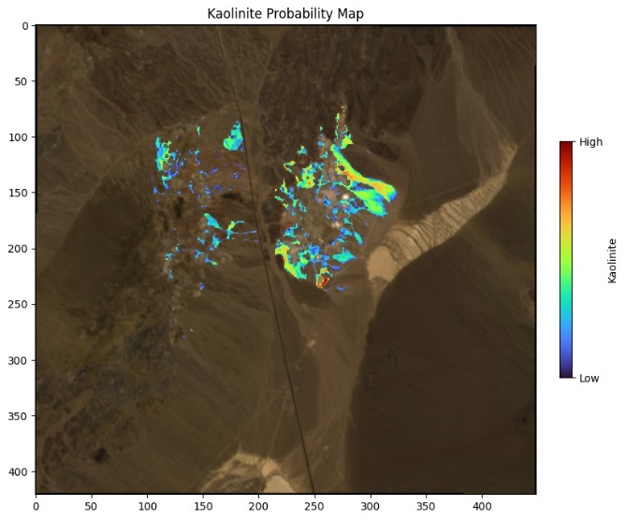
Fig. 2 Kaolinite Probability Map
Figure 3 provides a spectral comparison between the reflectance signature extracted from a pixel at Row 230, Column 260 and the reference spectrum for kaolinite. The close similarity in spectral features—particularly the absorption features around 2.2 µm—further validates the classification accuracy and confirms the presence of kaolinite at the selected location.
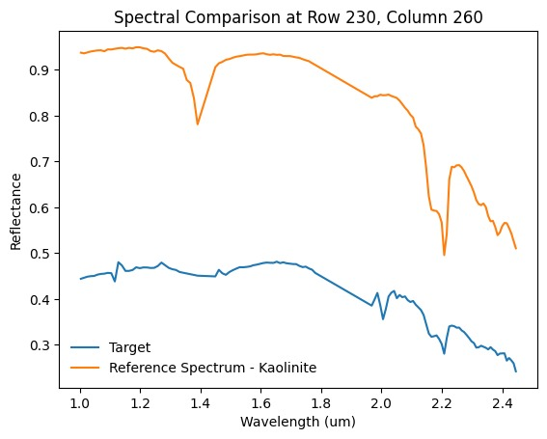
Fig. 3 Spectral Comparison

4.1 Spectral Angle Distribution and Homogeneity
The Spectral Angle Distance (SAD) histogram for candidate pixels (Figure 4) reveals that the majority of detected spectra have SAD values clustered between 0.065–0.070 radians. A steep increase in the cumulative distribution function (CDF) beginning at 0.055 radians indicates low diversity among the spectral angles, implying a high degree of spectral similarity between TOA-observed spectra and the BOA reference spectra derived using atmospheric correction. This suggests that the dual-regression model successfully reduces TOA variability and improves spectral alignment with BOA targets, enhancing confidence in matched signatures.
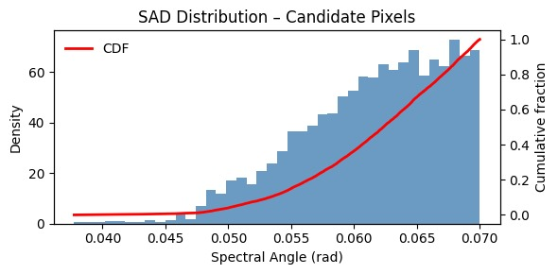
Fig. 4 SAD Distribution of Pixels

4.2 Match-Entropy Confidence Mapping
The Match-Entropy Map (Figure 5) provides a spatial representation of model uncertainty. Entropy, computed from the contrastive feature space, acts as a proxy for confidence in spectral match quality. Lower entropy (darker regions) indicates that the TOA spectra, once processed by the model, closely align with known BOA spectral signatures of minerals such as kaolinite. Higher entropy zones are indicative of either mixed pixels, residual atmospheric effects, or spectral confusion. These results reinforce the importance of learning-based denoising techniques, which extend beyond deterministic atmospheric correction by enabling adaptive feature transformation under diverse surface and illumination conditions.
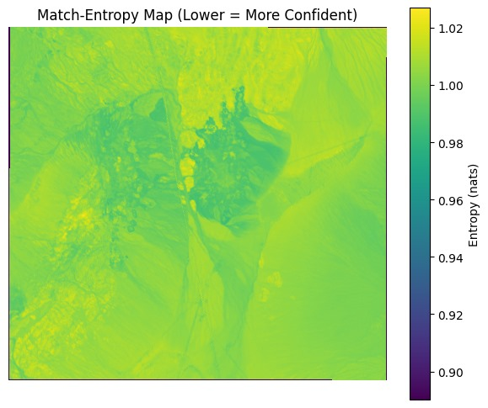
Fig. 5 Entropy Map

4.2 Cluster Compactness in PCA-Transformed Spectral Space
The PCA-space Compactness analysis (Figure 6) examines the spectral coherence within clusters formed after model embedding. Clusters 1 and 2 exhibit tight intra-cluster distances, suggesting high purity in mineralogical content and effective spectral separation. In contrast, Cluster 5 displays higher intra-cluster variability, possibly capturing noisy pixels or areas affected by unresolved TOA-to-BOA distortion. This underscores the importance of using feature-aware models that prioritize discriminability in the learned spectral space, rather than relying solely on direct radiometric correction.
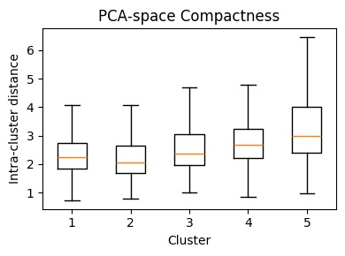
Fig. 6 PCA-Space Compactness

4.4 Confidence Map for Kaolinite Detection
The Kaolinite Confidence Map (Figure 7) demonstrates the practical outcome of the trained model in real-world mineral mapping. High-confidence predictions (yellow/white areas) correspond to geologically plausible kaolinite zones, confirming that the model effectively learned the spectral correspondence between TOA inputs and BOA-based reference signatures. The confidence score aids in filtering ambiguous detections, providing a robust tool for field validation and downstream geological analysis. This layer of certainty would not be possible with traditional rule-based TOA–BOA conversion pipelines alone.
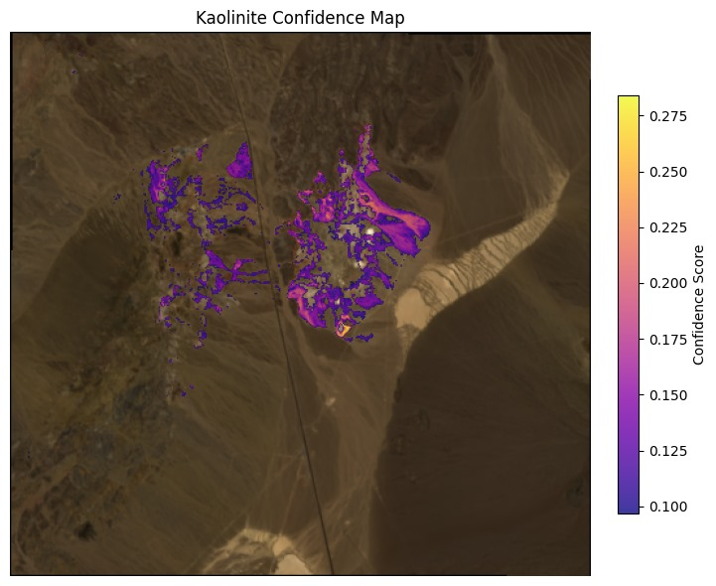
Fig. 7 Confidence Map
5 Conclusion and Future Scope

4.2 Summary of the Main Findings
Hyperspectral imaging (HSI) has proven to be a powerful technique for mineral detection due to its ability to capture detailed spectral information across a broad range of wavelengths. Compared to traditional imaging techniques, HSI offers greater specificity and accuracy in identifying minerals through their unique spectral signatures. Several spectral matching techniques—such as Spectral Angle Mapper (SAM), Euclidean Minimum Distance (EMD), and Constrained Energy Minimization (CEM)—have been evaluated in the literature. Among these, SAM has consistently demonstrated superior robustness to illumination and albedo variations, making it particularly well-suited for mineral classification tasks under varying environmental conditions. Additionally, the integration of machine learning approaches such as Convolutional Neural Networks (CNNs), Support Vector Machines (SVMs) [5], and Random Forests has shown potential to further automate and enhance the mineral detection process.
This study advances the field by introducing a dual-regression reflectance conversion model that transforms Top-of-Atmosphere (TOA) reflectance into Bottom-of-Atmosphere (BOA) reflectance, bypassing the need for traditional atmospheric correction algorithms like 6S or Sen2Cor. Unlike physics-based models, which require extensive metadata and external inputs, this data-driven model learns directly from paired TOA-BOA examples to perform atmospheric correction. The corrected BOA spectra are then used for mineral detection using SAM, benefiting from improved spectral fidelity and consistency.
Quantitative evaluation using Spectral Angle Distance (SAD) reveals a tightly clustered distribution of SAD values below 0.07 radians, indicating high similarity between the model-generated BOA reflectance and the reference kaolinite spectra. The cumulative distribution plot further confirms that the majority of candidate pixels exhibit minimal spectral deviation. Visual analysis of the Kaolinite Probability Map and individual spectral profiles, such as at Row 230, Column 260, shows accurate detection of kaolinite-rich regions with strong alignment around key absorption features, notably near 2.2 µm.
By replacing traditional TOA-to-BOA algorithms with a trainable deep learning-based model, the proposed approach enhances processing speed, improves scalability across scenes and sensors, and supports seamless integration into end-to-end mineral detection pipelines. Despite these advancements, challenges remain in handling HSI’s high dimensionality and ensuring robustness across varied atmospheric and surface conditions. Future work will aim to extend the model to a wider range of minerals, refine its generalizability, and optimize computational performance for real-time or onboard deployment in operational remote sensing missions.

4.2 Future Scope
This research underscores the transformative potential of hyperspectral imaging (HSI) in mineral detection, particularly when combined with advanced machine learning and data-driven atmospheric correction techniques. The introduction of a dual-regression model for TOA-to-BOA reflectance conversion represents a significant step toward automating and streamlining the mineral detection pipeline. By eliminating the need for traditional correction algorithms, the proposed approach enhances processing efficiency and scalability, making HSI more accessible for large-scale and real-time applications.
While challenges such as high dimensionality, sensor variability, and computational complexity persist, continued advancements in deep learning architectures, dimensionality reduction methods, and hardware acceleration are poised to address these limitations. As these technologies mature, HSI is expected to play an increasingly vital role in mineral exploration, geological mapping, environmental monitoring, and planetary science-contributing to both scientific discovery and industrial innovation [6][7].
The integration of HSI with emerging technologies such as UAV-based sensors and satellite constellations will enable rapid, large-scale, and near-real-time mineral mapping, improving exploration accuracy while reducing environmental impact and operational costs. Moreover, advancements in sensor technology-covering broader spectral ranges from VNIR to LWIR-and the incorporation of 3D surface profiling will facilitate more precise spatial and compositional analysis of mineral deposits [23].
Ultimately, as hardware becomes more affordable and machine learning algorithms grow increasingly sophisticated, hyperspectral imaging is set to become an indispensable tool across mining, environmental science, and planetary exploration. Its continued advancement will drive innovation, foster sustainability, and enable more informed decision-making well into the future.
5 Acknowledgements
We express our deepest gratitude and special thanks to our mentor, Dr. Deepa Parasar, Faculty of the Department of Computer Science and Engineering at Amity University, Mumbai. Her valuable guidance and insightful feedback have been instrumental in shaping this work, providing us with the direction and expertise necessary for its successful completion.
6 References
[1] R. Booysen et al., “Detection of REEs with lightweight UAV-based hyperspectral imaging.,” Springer Science and Business Media LLC, [Online]. Available: https://www.nature.com/articles/s41598-020-74422-0
[2] Z. Ren, Q. Zhai, and L. Sun, “A Novel Method for Hyperspectral Mineral Mapping Based on Clustering-Matching and Nonnegative Matrix Factorization,” Jan. 2022, [Online]. Available: https://www.mdpi.com/2072-4292/14/4/1042
[3] N. Hasan, K. M. Hasan, M. T. Islam, and S. Siddique, “Investigation of Minerals Using Hyperspectral Satellite Imagery in Bangladesh,” Dec. 2022, [Online]. Available: https://arxiv.org/abs/2212.04468
[4] F. D. van der Meer and X. Jia, “Collinearity and orthogonality of endmembers in linear spectral unmixing,” International Journal of Applied Earth Observation and Geoinformation, vol. 18, pp. 491–503, Aug. 2012, doi: 10.1016/J.JAG.2011.10.004.
[5] F. Melgani and L. Bruzzone, “Classification of hyperspectral remote sensing images with support vector machines,” IEEE Transactions on Geoscience and Remote Sensing, vol. 42, no. 8, pp. 1778–1790, Aug. 2004, doi: 10.1109/tgrs.2004.831865.
[6] L. C. Rowan and J. C. Mars, “Lithologic mapping in the Mountain Pass, California area using Advanced Spaceborne Thermal Emission and Reflection Radiometer (ASTER) data,” Remote Sensing of Environment, vol. 84, no. 3, pp. 350–366, Mar. 2003, doi: 10.1016/s0034-4257(02)00127-x.
[7] R. Booysen, S. Lorenz, M. Kirsch, R. Jackisch, R. Zimmermann, and R. Gloaguen, “Hyperspectral imaging with UAVs for mineral exploration,” Second EAGE Workshop on Unmanned Aerial Vehicles, pp. 1–3, 2021, doi: 10.3997/2214-4609.2021629012.
[8] W. Wenzheng, Z. Baojun, T. Linbo, Z. Shichao, and F. Fan, “Fusion‐based spectral matching method for hyperspectral target detection,” The Journal of Engineering, vol. 2019, no. 20, pp. 6741–6744, Sep. 2019, doi: 10.1049/joe.2019.0322.
[9] M. S. Shaikh, K. Jaferzadeh, B. Thörnberg, and J. Casselgren, “Calibration of a Hyper-Spectral Imaging System Using a Low-Cost Reference,” Sensors, vol. 21, no. 11, p. 3738, May 2021, doi: 10.3390/s21113738.
[10] F. A. Kruse, “Mineral Mapping with AVIRIS and EO-1 Hyperion,” Proceedings of the 12th JPL Airborne Earth Science Workshop, 2004. [Online]. Available: https://ntrs.nasa.gov/citations/20050192448
[11] R. Clark and Gov, “USGS Spectroscopy Lab: Spectroscopy of Rocks and Minerals, and Principles of Spectroscopy of Rocks and Minerals, and Principles of Spectroscopy.” Available: https://www.ugpti.org/smartse/research/citations/downloads/Clark-Manual_Spectroscopy_Rocks_Minerals_Book-1999.pdf
[12] Mohamadou Ahamadou, M. N. Stella, and Meying Arsène, “ASTER Data Processing by Discrete Wavelets Transform and Band Ratio Techniques for the Identification of Lineaments and Hydrothermal Alteration Zones in Poli, North Cameroon,” Journal of Geoscience and Environment Protection, vol. 11, no. 09, pp. 216–232, Jan. 2023, doi: 10.4236/gep.2023.119014.
[13] N. Okada, Y. Maekawa, N. Owada, K. Haga, A. Shibayama, and Y. Kawamura, “Automated identification of mineral types and grain size using hyperspectral imaging and deep learning for mineral processing,” Minerals, vol. 10, no. 9, p. 809, Sep. 2020, doi: 10.3390/min10090809.
[14] A. Berk, L. S. Bernstein, and D. C. Robertson, MODTRAN: A Moderate Resolution Model for LOWTRAN. U.S. Air Force Geophysics Laboratory, 1989, GL-TR-89-0122. [Online]. Available: https://lpdaac.usgs.gov/documents/1153/AST_09T_User_Guide_V4.pdf
[15] F. A. Kruse et al., “The spectral image processing system (SIPS)—interactive visualization and analysis of imaging spectrometer data,” Remote Sensing of Environment, vol. 44, no. 2, pp. 145–163, May 1993, doi: 10.1016/0034-4257(93)90013-N.
[16] L. Guanter et al., “The ENMAP Spaceborne Imaging Spectroscopy Mission for Earth Observation,” Remote Sensing, vol. 7, no. 7, pp. 8830–8857, Jul. 2015, doi: 10.3390/rs70708830
[17] B. Yousefi et al., “Mineral identification in hyperspectral imaging using Sparse-PCA,” Proceedings of SPIE, the International Society for Optical Engineering/Proceedings of SPIE, vol. 9861, p. 986118, May 2016, doi: 10.1117/12.2224393.
[18] F. A. Kruse, “Use of airborne imaging spectrometer data to map minerals associated with hydrothermally altered rocks in the northern grapevine mountains, Nevada, and California,” Remote Sensing of Environment, vol. 24, no. 1, pp. 31–51, Feb. 1988, doi: 10.1016/0034-4257(88)90004-1.
[19] Y. Attallah, Ehlem Zigh, and A. P. Adda, “Optimized 3D-2D CNN for automatic mineral classification in hyperspectral images,” Reports on Geodesy and Geoinformatics, vol. 118, no. 1, pp. 82–91, Nov. 2024, doi: 10.2478/rgg-2024-0017.
[20] X. Feng, L. He, Q. Cheng, X. Long, and Y. Yuan, “Hyperspectral and Multispectral Remote Sensing Image Fusion Based on Endmember Spatial Information,” Remote Sensing, vol. 12, no. 6, p. 1009, Mar. 2020, doi: 10.3390/rs12061009.
[21] D. Manolakis and G. Shaw, “Detection algorithms for hyperspectral imaging applications,” IEEE Signal Processing Magazine, vol. 19, no. 1, pp. 29–43, 2002, doi: 10.1109/79.974724
[22] G. A. Shaw and H.-h. K. Burke, "Spectral Imaging for Remote Sensing," Lincoln Laboratory Journal, vol. 14, no. 1, pp. 3-28, 2003.
[23] F. Koerting et al., “VNIR-SWIR Imaging Spectroscopy for Mining: Insights for Hyperspectral Drone Applications,” Mining, vol. 4, no. 4, pp. 1013–1057, Nov. 2024, doi: 10.3390/mining4040057.

Additional Information

I) Submission Specification for Conference Papers
This ‘Submission Specification for Conference Papers’ document provides instructions for the submission of Conference Papers for publication on the IET Digital Platform

This document is to be used in conjunction with the ‘Manuscript-template.dotx’.
The Conference Paper is to be prepared in MS Word format and then printed to PDF. The authors should submit Word version as well as PDF version of their conference papers (Please see the section II PDF format requirements).

Submission requirements
Word Template layout
PDF format requirements

1. Submission requirements
Conference papers must satisfy the following requirements:

1.1 Manuscript Submission

1.1.1 Originality: Is the work scientifically rigorous, accurate and novel? Does the work contain significant additional material to that already published? Has its value been demonstrated?

1.1.2 Plagiarism: All conference papers submitted to the IET for publication must record original work which has not been published previously. Any alleged cases of plagiarism will be dealt with according to the ‘IET Policy in Relation to Plagiarism, Infringement of Copyright and Infringement of Moral Rights and Submission to Multiple Publications’.

1.1.3 Multiple submissions: The IET does not permit manuscripts included in its conference proceedings to be simultaneously under review for another conference or publication.
Once a case of multiple submissions has been established, the paper/s in question will be immediately declined for publication by the IET.

1.1.4 Relevance: Is the material appropriate to the scope of the conference to which it is submitted?

1.1.5 Clarity: Is the English clear and well written? Poorly written English may obscure the scientific merit of your paper. Are the ideas expressed clearly and concisely? Are the concepts understandable?

2. Post-print Policy

2.1.1 The author may post post-prints of their conference papers published by the IET on repositories, servers and websites of any sort, provided that these servers are operated by the author's institution or the funding body contributing to the research. To comply with funding requirements, authors may also deposit their conference papers in repositories (or mirror sites) designated by the funding body.

The conditions attached to this are as follows:

2.1.2 Access to such servers is not for commercial use and does not depend on payment of access, subscription, or membership fees.

2.1.3 The following wording clearly appears on the front page of the post-print:

"This paper is a post-print of a paper submitted to and accepted for publication in Conference Proceedings of conference title and is subject to Institution of Engineering and Technology Copyright. The copy of record is available at IET Digital Library"

2.1.4 The post-print must be the author's version and not the IET version/PDF.

2.1.5 The post-print must not be posted prior to publication of the paper by the IET and when posted any preprint version should be removed.

3.1 Copyright

3.1.1 An author submitting a paper should ensure that he or she has the right to publish the paper and that it contains nothing defamatory. The IET will assume that all co-authors have agreed to the submission of any paper received.

3.1.2 Your conference paper must be accompanied by a signed copyright form.

3.1.3 Copyright: Unless the paper is either "United Kingdom Crown copyright" or "a work of the US Government and in the Public Domain", the Bylaws of the IET require that copyright should belong to the IET.

3.1.4 Right to publish: An author submitting a paper should ensure that he or she has the right to publish the paper and that it contains nothing defamatory. The IET will assume that all co-authors have agreed to the submission of any paper received.

4.1 Permissions to Reproduce

4.1.1 All authors must secure permission from the copyright holder for reproducing previously published text, figures and tables. The source of the reproduced material must be given in full and the words 'Reproduced by permission of .....' included with the illustration.

II) PDF format requirements

All PDFs shall be set as follows:

File names: The PDF file names will be consecutively numbered in the order that the papers are to be published:

- ‘01.pdf’ consecutively to ‘99.pdf’
(for up to 99 files within the conference proceedings).

- ‘001.pdf’ consecutively to ‘999.pdf’
(for up to 1000 files within the conference proceedings).

Version: Adobe PDF Version 1.4 (Acrobat 5)

Fonts: All fonts shall be 'embedded subset'.

Document Properties:

Title: Full title of the paper.
Authors: All contributing author names to be included.
Subject: Full conference name and abbreviation.
Keywords: Keywords as set in the paper at Item 2, Keywords.

IV) IET Digital Library and Inspec Indexing requirements

Papers that will be submitted for publication on the IET Digital Library, and subsequent indexing in Inspec, IEEE Xplore and EI Compendex, must be submitted in the following format:

All PDFs must be in the format as specified as stated in Paragraph 3 above (PDF format requirement).

An event programme must be supplied. This will contain details of the event, title of the event, dates of the event, venue and programme details.

